Car Service & Maintenance Reminder App
Automated Testing using Appium & Java

Capstone Project Documentation

Application Used:
Drivvo – Car Maintenance Reminder App

Candidate Id & Name:
55926 – Konijeti Yamini

Scan to view live project profile

TABLE OF CONTENTS
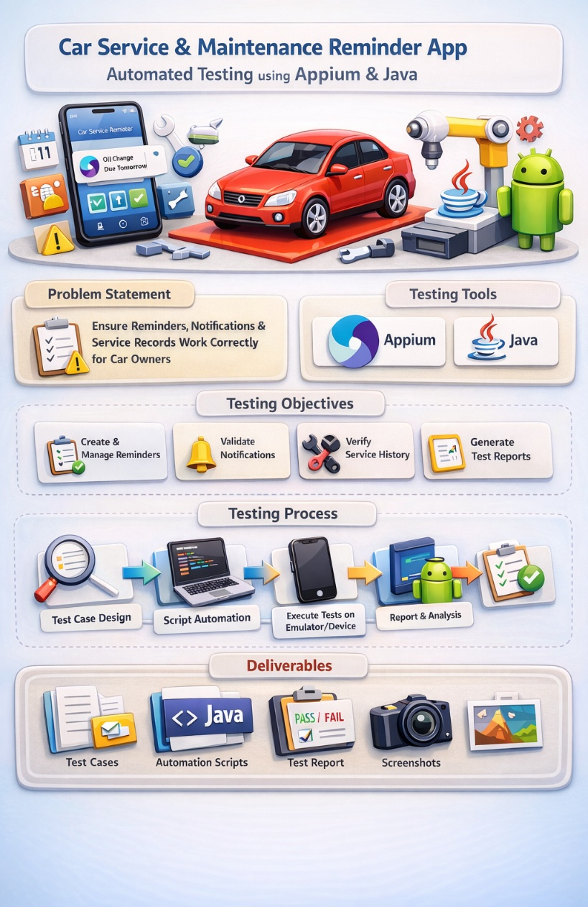
- Abstract
- Introduction
- Problem Statement
- Real World Scenario
- Objectives of the Project
- Terminologies
- Application Overview – Drivvo
- Application Architecture
- Automation Framework Architecture
- Environment Setup
- Test Case Design
- Detailed Test Cases
- Automation Implementation Using Appium and Java
- Automating Add Reminder Functionality
- Automating Edit Reminder Functionality
- Automating Delete Reminder Functionality
- Screenshot Capture on Test Failure
- Test Execution Process
- Test Execution Report
- Challenges Faced During Implementation
- Solutions Implemented
- Industry Relevance of the Automation Framework
- Deliverables
- Learning Outcomes
- Future Enhancements
- Conclusion
- References

ABSTRACT
This project presents a comprehensive implementation of mobile automation testing for a Car Service & Maintenance Reminder application using Appium and Java. The objective of this project is to validate the reliability and correctness of reminder management functionalities in a real-world vehicle maintenance application.
Vehicle maintenance plays a critical role in ensuring safety, performance, and compliance with legal regulations. Car owners are required to perform periodic servicing, oil changes, insurance renewals, and pollution control checks. However, due to busy schedules and lack of tracking systems, these important tasks are often forgotten.
To solve this issue, mobile applications such as Drivvo provide reminder management systems. However, the effectiveness of such applications depends entirely on the accuracy of reminder functionality.
This project focuses on automating the core reminder operations, including:
- Adding a service reminder (Oil Change)
- Editing an existing reminder
- Deleting a reminder
- Capturing screenshots on failure
- Generating automated HTML reports
The automation framework was developed using Java and Appium with UiAutomator2 driver for Android devices. The project demonstrates practical mobile automation testing concepts aligned with industry standards.

INTRODUCTION

With the rapid growth of smartphone usage, mobile applications have become an essential part of daily life. From banking to healthcare and vehicle management, users rely on mobile apps for convenience and efficiency.

One important category of mobile applications is vehicle maintenance reminder systems. Car owners must regularly monitor:

Periodic servicing

Engine oil changes

Insurance renewal dates

Pollution Under Control (PUC) certificate validity

Failure to maintain vehicles properly can result in:

Reduced vehicle performance

Increased maintenance cost

Safety risks

Legal penalties

Mobile applications help solve this problem by allowing users to create and manage reminders.

However, if reminder functionalities fail — such as not saving correctly, not updating properly, or not deleting — the application becomes unreliable. Therefore, automation testing becomes necessary.

This project implements mobile automation testing using Appium and Java to ensure that reminder management features operate correctly.

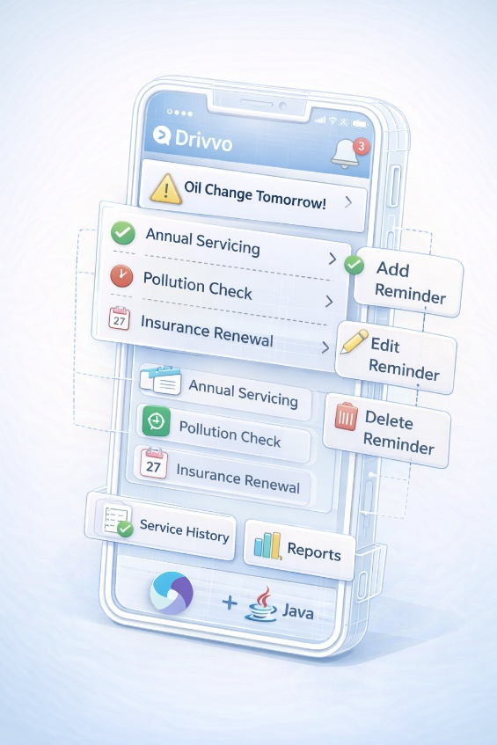
PROBLEM STATEMENT
Vehicle maintenance is a recurring and essential responsibility for car owners. While reminder applications assist users in tracking important maintenance activities, their reliability is crucial.
The problem addressed in this project is:
How can a mobile-based Car Service & Maintenance Reminder application be reliably tested using Appium and Java to ensure reminder creation, update, and deletion functionalities work correctly across Android devices?
To solve this, an automated testing solution is developed that validates core reminder operations.

REAL WORLD SCENARIO

Consider a working professional who owns a car. Due to daily responsibilities, they forget to change engine oil after reaching 5000 km.

They install Drivvo to manage reminders.

They:

Add Oil Change reminder

Later modify it

Finally delete it after service completion

If any of these steps fail, user trust is lost.

Although the application supports reminders for:

Periodic servicing

Insurance renewal

Pollution control checks

The automation implemented in this project primarily validates the Oil Change reminder workflow.

OBJECTIVES OF THE PROJECT

The objectives of this project are:

To understand mobile automation testing using Appium and Java

To design test cases for reminder management

To automate Add, Edit, and Delete reminder functionalities

To implement screenshot capture on failure

To generate automated HTML test reports

To simulate real-world mobile testing scenarios

TERMINOLOGIES

1 Appium

Appium is an open-source mobile automation framework used to test Android and iOS applications.

2 Java

Java is used to write automation scripts.

3 Test Automation

Test automation refers to executing test cases using scripts instead of manual testing.

4 Android Application

Mobile application designed for Android operating system.

5 Test Case

A structured scenario to validate a specific functionality.

6 Smoke Testing

Basic validation to ensure major functionality works.

7 Regression Testing

Re-testing application after changes.

8 UI Testing

Validating user interface elements.

APPLICATION OVERVIEW



The application used in this project is Drivvo.

Features include:

Add vehicle

Track fuel expenses

Add service reminders

Maintain service history

This project automates only reminder management
APPLICATION ARCHITECTURE

The mobile application follows layered architecture:

User → UI Layer → Business Logic → Data Storage

When reminder is added:

User inputs data

Application validates

Data stored internally

Displayed in reminder list

AUTOMATION FRAMEWORK ARCHITECTURE

Automation flow:

Java Script → Appium Client → Appium Server → Android Emulator → Drivvo App

Components:

UiAutomator2Options

AndroidDriver

Locators (ID, XPath)

Screenshot utility

HTML report generator
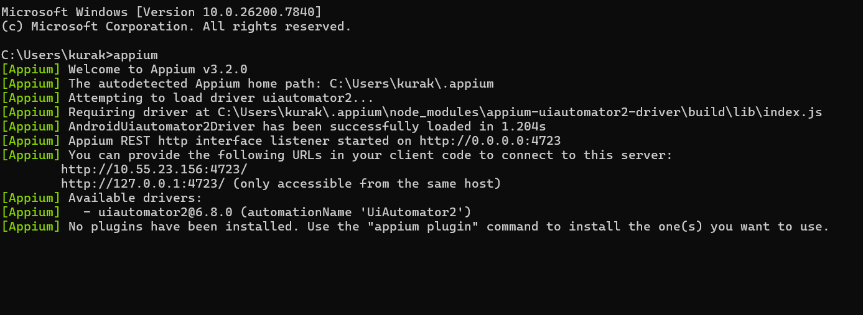

ENVIRONMENT SETUP
Describe:
- Java installation
- Android Studio setup
- Emulator creation
- Appium installation
- Device configuration
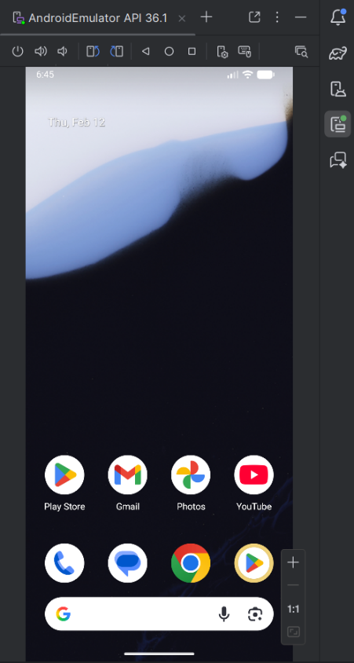
Capabilities used in code:
- Platform Name
- Automation Name
- Device Name
- App Package
- App Activity
- No Reset
- New Command Timeout

TEST CASE DESIGN
In this project, test cases were designed to validate the core functionalities of the Car Service & Maintenance Reminder application (Drivvo).
The main focus was to ensure that important features such as adding, editing, and deleting reminders work correctly without any errors.
Before writing automation scripts, the application was explored manually to understand how a user interacts with it. Based on user actions, the following test scenarios were identified.

12.1 Key Functionalities Identified
The following core features were selected for automation:
- Add a new service reminder
- Edit an existing reminder
- Delete a reminder
These features are critical because they directly affect the user experience.

12.2 Designed Test Cases

TC01 – Add Reminder
Objective:
To verify that a user can successfully add a new service reminder.
Expected Result:
The reminder should be saved and displayed in the reminder list.

TC02 – Edit Reminder
Objective:
To verify that an existing reminder can be modified.
Expected Result:
The updated reminder details should be reflected correctly in the list.

TC03 – Delete Reminder
Objective:
To verify that a reminder can be deleted successfully.
Expected Result:
The reminder should be removed from the list.

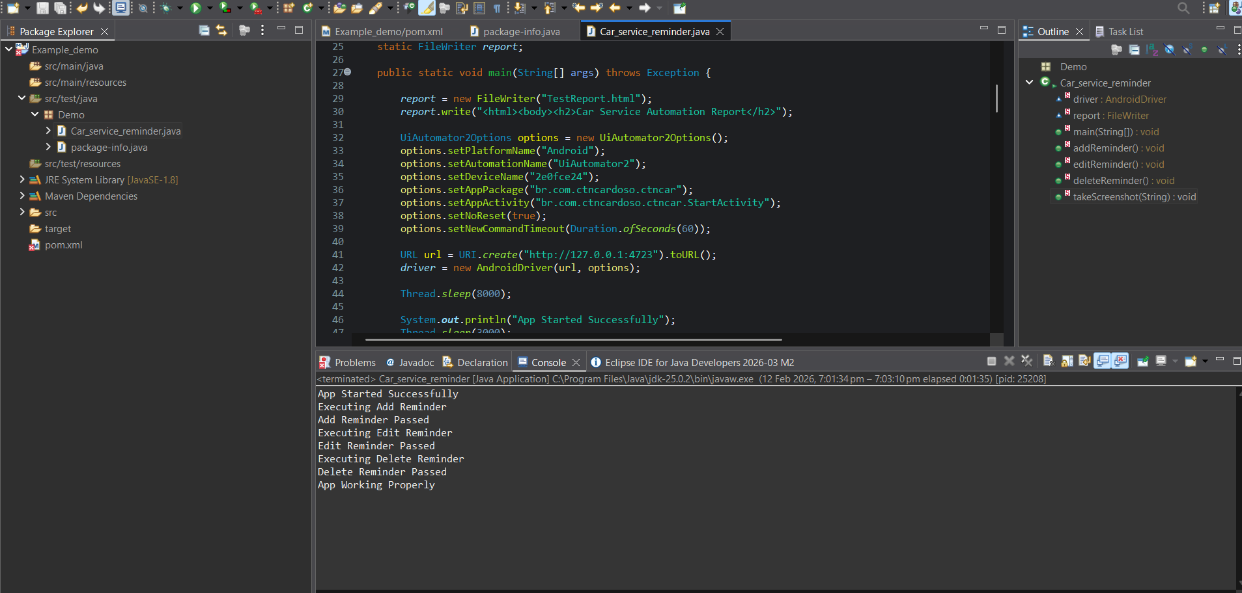
DETAILED TEST CASES
TC ID | Test Scenario | Expected Result | Actual Result | Status
TC01 | Add Reminder | Reminder saved | Reminder displayed in list | Pass
TC02 | Edit Reminder | Updated details saved | Details updated successfully | Pass
TC03 | Delete Reminder | Reminder removed | Reminder no longer visible | Pass

AUTOMATION IMPLEMENTATION
In this project, automation was implemented using Appium and Java to interact with the Drivvo mobile application. The automation framework was designed to simulate real user actions such as clicking buttons, entering text, and validating reminder details.
1. Desired Capabilities:
Desired Capabilities are used to configure the mobile device and application before starting automation.
They provide important information such as:
- Platform name (Android)
- Device name (Emulator or Real Device)
- App package name
- App activity
These details help Appium understand which device and application it needs to control during execution.
In simple terms, DesiredCapabilities act as a bridge between the automation script and the mobile device.

2. Driver Initialization
The Appium driver is responsible for controlling the mobile application.
During driver initialization:
- A connection is established between the Java test script and the Appium server.
- The Appium server then connects to the Android emulator or real device.
- Once the connection is successful, automation can begin.
Without driver initialization, no test actions can be performed.

3. Locator Strategies
Locator strategies are used to identify UI elements in the mobile application.
In this project, the following locators were used:
- ID (Preferred method)
- XPath (Used when ID is not available)
Using stable locators ensures reliable automation and reduces execution failures.
Choosing the correct locator strategy improves test stability and performance.
4. Wait Mechanisms
Mobile applications may take time to load elements.
To handle this, wait mechanisms were used:
- Implicit Wait
- Explicit Wait
Waits ensure that the script interacts with elements only after they are fully loaded, preventing errors caused by timing issues.
This improves automation reliability.
AUTOMATING ADD REMINDER FUNCTIONALITY

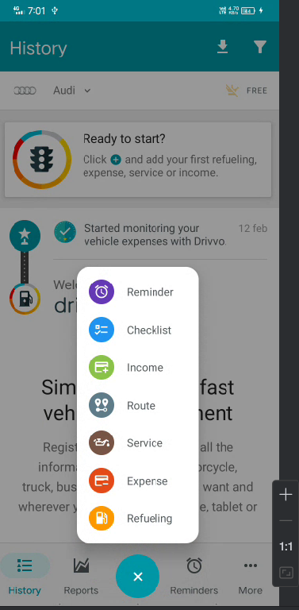
Step 1: Launch the Application
- Appium driver is initialized.
- The Drivvo app is launched on the Android device.
- We wait a few seconds to make sure the app loads properly.
Purpose: Start the application before performing any action.

Step 2: Click on “+” (Add) Icon
- The automation script finds the “+” icon using its ID.
- It performs a click action.
Purpose: This button opens the screen to create a new reminder.

Step 3: Select “Reminder” Option
- After clicking “+”, multiple options appear.
- The script selects the Reminder option.
Purpose: We want to create a reminder, not fuel entry or expense.

Step 4: Select “Service”
- The script selects the “Service” category.
- This tells the app that we are adding a service-related reminder.
Purpose: Oil Change comes under service type.

Step 5: Choose “Type of Service”
- The script clicks on “Type of Service”.
- A list of services appears.
- Using Android UI Automator scrolling, the script scrolls down.
- It selects Oil Change.
Purpose: Specify what kind of service reminder we are adding.

Step 6: Enter Odometer Value
- The script finds the odometer input field.
- It enters value: 5000 using sendKeys().
Purpose: Reminder should trigger after reaching 5000 km.

Step 7: Enable Date Option
- The script clicks the date checkbox.
- It opens the date picker.
- It selects a specific date (for example: 25 February 2026).
- It clicks OK.
Purpose: Set a reminder date for oil change.

Step 8: Enter Notes
- The script finds the notes field.
- It enters: “Change engine oil”
Purpose: Provide additional information for reminder.

Step 9: Click Save Button
- The script clicks on the Save button.
- The reminder gets stored in the application.

VALIDATION STEP
After clicking Save:
- The script waits for the screen to load.
- It checks whether the Oil Change reminder appears in the reminder list.
If reminder is visible → Test Case PASS
If reminder is not visible → Test Case FAIL (Screenshot captured)

AUTOMATING EDIT FUNCTIONALITY

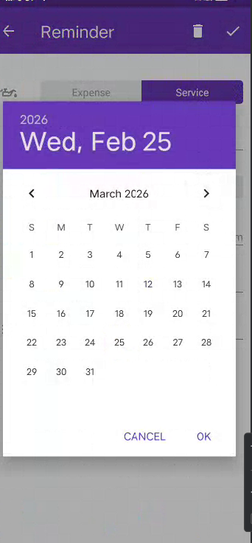
Step 1: Open Reminder Section
- After the app is launched, the script clicks on the “Reminders” tab at the bottom.
- This opens the list of all saved reminders.
Purpose: We need to access the existing reminder before editing it.

Step 2: Select Existing Reminder
- The script finds the Oil Change reminder from the list.
- It clicks on that reminder.
Purpose: Open the reminder details screen so we can modify it.

Step 3: Clear Odometer Field
- The script locates the odometer input field.
- It uses the clear() method to remove the existing value (5000).
Purpose: Remove old value before entering a new one.

Step 4: Enter New Odometer Value
- After clearing, the script enters a new value: 6000 using sendKeys().
Purpose: Update the reminder to trigger at 6000 km instead of 5000 km.

Step 5: Change the Date
- The script clicks on the Date field.
- The date picker opens.
- It clicks on Next Month.
- Selects a new date (for example: 10 March 2026).
- Clicks OK.
Purpose: Update the reminder schedule date.

Step 6: Click Save Button
- The script clicks the Save button.
- The updated details are stored in the application.
Purpose: Finalize the modification process.

AUTOMATING DELETE REMINDER FUNCTIONALITY

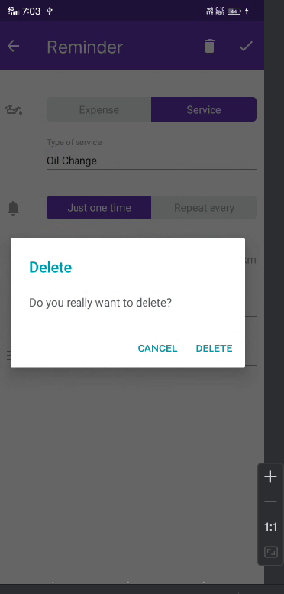
Step 1: Open the Reminder
- After editing is completed, the script stays on the reminder list screen.
- The script finds the Oil Change reminder from the list.
- It clicks on that reminder.
Purpose: Open the reminder details screen before deleting it.

Step 2: Click on Delete Button
- On the reminder details screen, the script locates the Delete button.
- It performs a click action on the Delete button.
Purpose: Initiate the deletion process.

Step 3: Confirm Deletion
- A confirmation popup appears asking:
“Are you sure you want to delete?”
- The script clicks on the “Yes” button (Confirm option).
Purpose: Confirm that the reminder should be permanently removed.

SYNCHRONIZATION HANDLING
Synchronization is important in mobile automation because the application may take time to load screens or UI elements. If the automation script tries to interact with elements before they are fully loaded, it can result in errors like element not found.
In this project, Thread.sleep() is used to pause the execution for a few seconds between actions. This ensures that:
- The application screen loads completely
- Buttons and input fields become visible
- The next action is performed only after the previous action finishes
Although Thread.sleep() is a simple waiting method and not the most advanced approach, it helps maintain stable test execution in this automation framework.

SCREENSHOT CAPTURE IMPLEMENTATION
Step 1: Detect Test Failure
If any exception occurs during execution, the test is marked as failed.
Step 2: Capture Screenshot
The getScreenshotAs() method is used to capture the current screen of the application.
Step 3: Generate Timestamp
A timestamp is created using date and time format to make the screenshot name unique.
Step 4: Save Screenshot
The screenshot file is saved in the project folder with a name like:
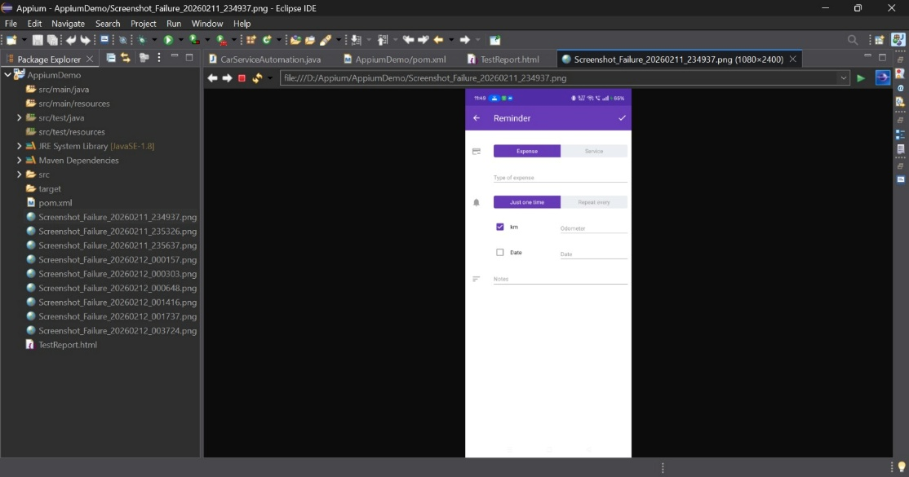

TEST EXECUTION PROCESS – Step by Step

Step 1: Start Appium Server
First, the Appium server is started.
This allows communication between your Java automation script and the Android device or emulator.
Without starting Appium, automation cannot run.

Step 2: Connect Emulator or Real Device
Next, the Android emulator (or real device) is launched and connected.
The device must be ready before running the script.
This is where the mobile application will be tested.

Step 3: Run Java Main Class
You run your Java file (Car_service_reminder.java) from your IDE (Eclipse/IntelliJ).
This starts the automation execution.

Step 4: Driver Initialization
The AndroidDriver is initialized using UiAutomator2Options.
This connects:
Java Script → Appium Server → Android Device → Drivvo App
Now the automation session is active.

Step 5: Test Methods Execute
After driver initialization, the following methods run one by one:
- addReminder()
- editReminder()
- deleteReminder()
Each method performs actions and validates the result.
If any error occurs, a screenshot is captured.

Step 6: HTML Report Generated
After all methods complete:
- A simple HTML report (TestReport.html) is generated.
- It shows whether the test cases passed or failed.
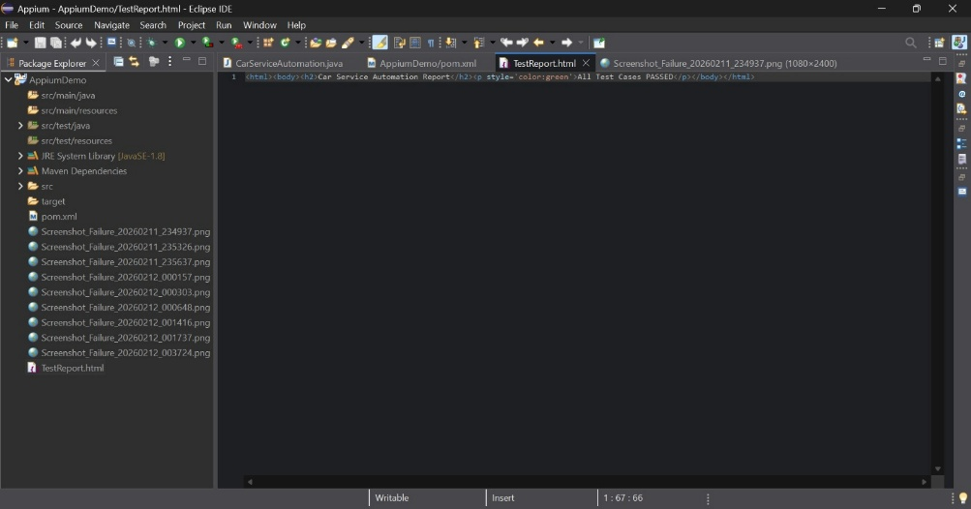

CHALLENGES FACED

1. Synchronization Issues
Sometimes the app takes time to load screens or buttons.
If the script runs too fast, it tries to click elements before they appear.
This caused “element not found” errors.

2. XPath Stability
Some elements did not have proper ID values.
So XPath was used to locate them.
But XPath can break easily if the UI structure changes, which made automation slightly unstable.

3. Emulator Slowness
The Android emulator sometimes worked slowly.
Because it uses system RAM and CPU, the app loading became delayed.
This increased execution time and sometimes caused timing issues.

4. Date Picker Handling
Selecting a specific date in the date picker was slightly tricky.
The script had to correctly identify the date and click it.
If the date format or month changed, it required careful handling.

SOLUTIONS IMPLEMENTED

1. Added Sufficient Wait Time
To solve synchronization issues, proper waiting time was added using Thread.sleep().
This helped the app load completely before performing the next action.
It reduced “element not found” errors.

2. Used Stable Locators
Whenever possible, ID locators were used because they are faster and more reliable.
XPath was used only when ID was not available.
This improved test stability.

3. Verified Element Selection
Before finalizing the script, each UI element was checked carefully using Appium Inspector.
This ensured that the correct elements were being clicked and updated.

4. Handled Exceptions Properly
A try-catch block was used in the code.
If any test failed, the script captured a screenshot and marked the test as failed.
This made debugging easier and improved reporting.

INDUSTRY RELEVANCE
In real software companies, automation testing is very important. Mobile applications are updated regularly, and every new update must be tested to make sure old features are still working properly.
Automation helps in the following ways:
- It reduces manual testing effort.
- It saves time during regression testing.
- It ensures stable and reliable releases.
- It quickly identifies defects before the app is released to users.
The automation framework developed in this project can be improved further by:
- Using TestNG for better test execution and reporting.
- Implementing Page Object Model (POM) for better code structure and maintainability.
- Integrating with CI/CD tools so tests run automatically whenever new code is added.
Overall, this project reflects how mobile automation is used in real industry environments to improve application quality and reliability.
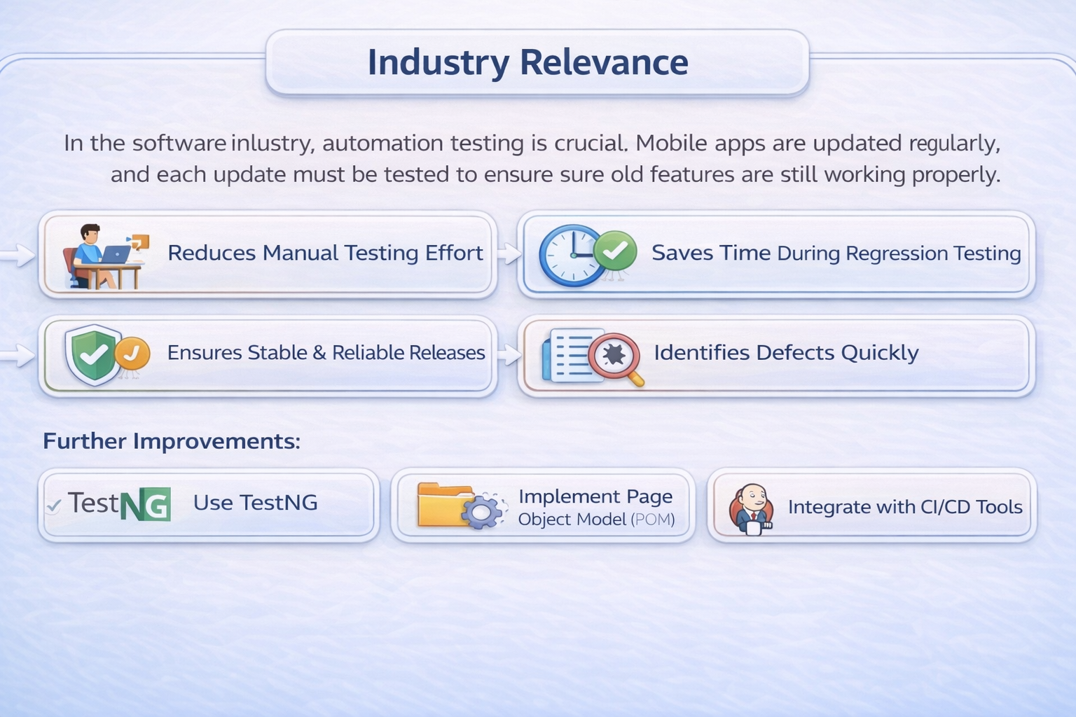

DELIVERABLES

1. Test Case Document
A document was prepared that contains all the test cases designed for the project.
It includes test case ID, scenario, expected result, actual result, and status (Pass/Fail).

2. Java Automation Script
Automation scripts were written using Java and Appium.
The script includes driver setup, add reminder, edit reminder, delete reminder, screenshot capture, and report generation.

3. HTML Report
After execution, a simple HTML report is generated.
It shows whether the test cases passed or failed.

4. Screenshots
Screenshots are captured automatically if any test case fails.
These screenshots help in identifying and debugging errors.

LEARNING OUTCOMES

Step 1: Understanding Mobile Automation
Learned how mobile applications can be tested automatically instead of manually.

Step 2: Hands-on Experience with Appium
Gained practical experience in using Appium to automate Android applications.

Step 3: Driver Configuration Knowledge
Understood how to initialize AndroidDriver and set desired capabilities properly.

Step 4: Element Identification
Learned how to locate mobile elements using ID, XPath, and AndroidUIAutomator.

Step 5: Handling Synchronization
Understood how to manage timing issues using waits to avoid execution errors.

Step 6: Debugging and Screenshot Capture
Learned how to capture screenshots when test cases fail for easy debugging.

Step 7: Report Generation
Implemented simple HTML report generation to show Pass/Fail results.

FUTURE ENHANCEMENTS – Step by Step

Step 1: Implement Page Object Model (POM)
Organize code better by separating page elements and test logic.

Step 2: Use TestNG Framework
Improve test execution structure and generate advanced reports.

Step 3: Automate Insurance Reminder
Add automation for insurance renewal reminders.

Step 4: Automate Pollution Reminder
Add automation for pollution control (PUC) reminders.

Step 5: CI/CD Integration
Integrate automation with CI/CD tools so tests run automatically after every build.
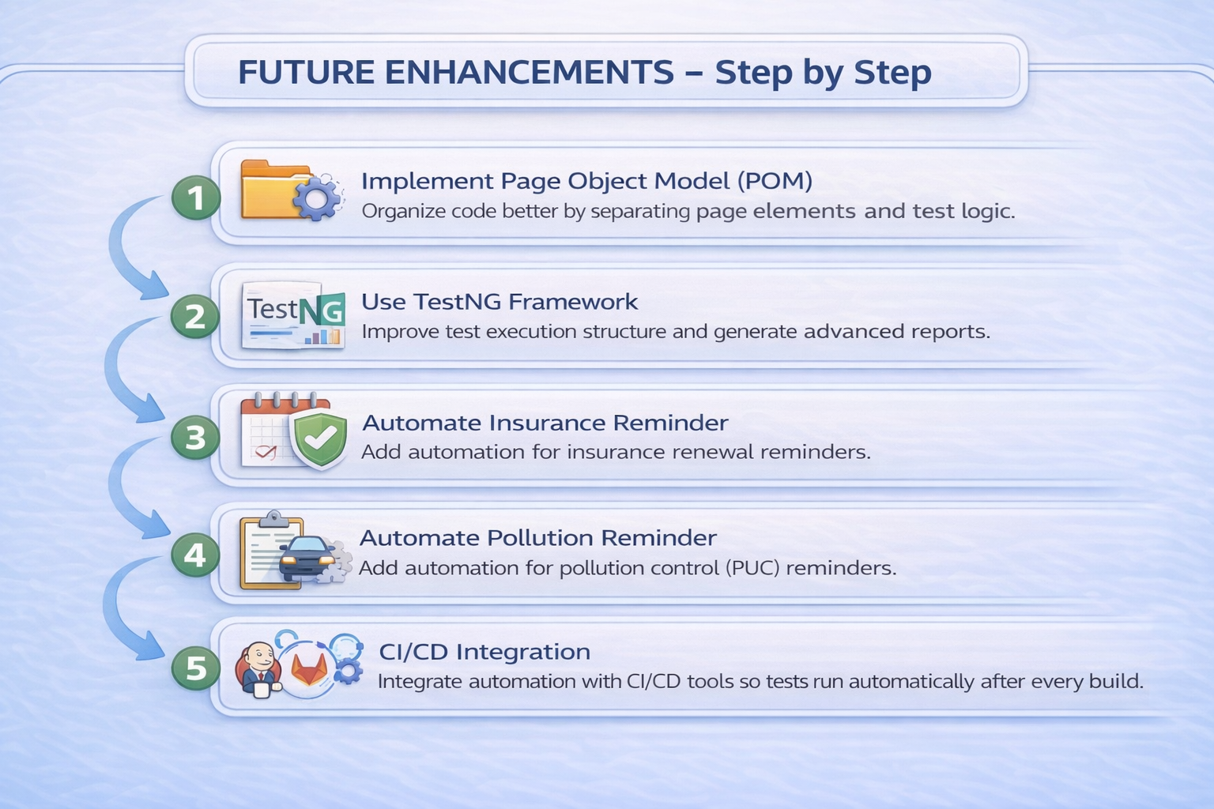

CONCLUSION
This project successfully automated the reminder management functionality of a Car Service & Maintenance Reminder mobile application using Appium and Java.
The framework validates:
- Oil Change reminder creation
- Reminder modification
- Reminder deletion
Although the application supports periodic servicing, insurance renewal, and pollution control reminders, this implementation primarily automates the Oil Change workflow.
The project demonstrates real-world mobile automation testing principles and provides a strong foundation for industry-level testing practices.

